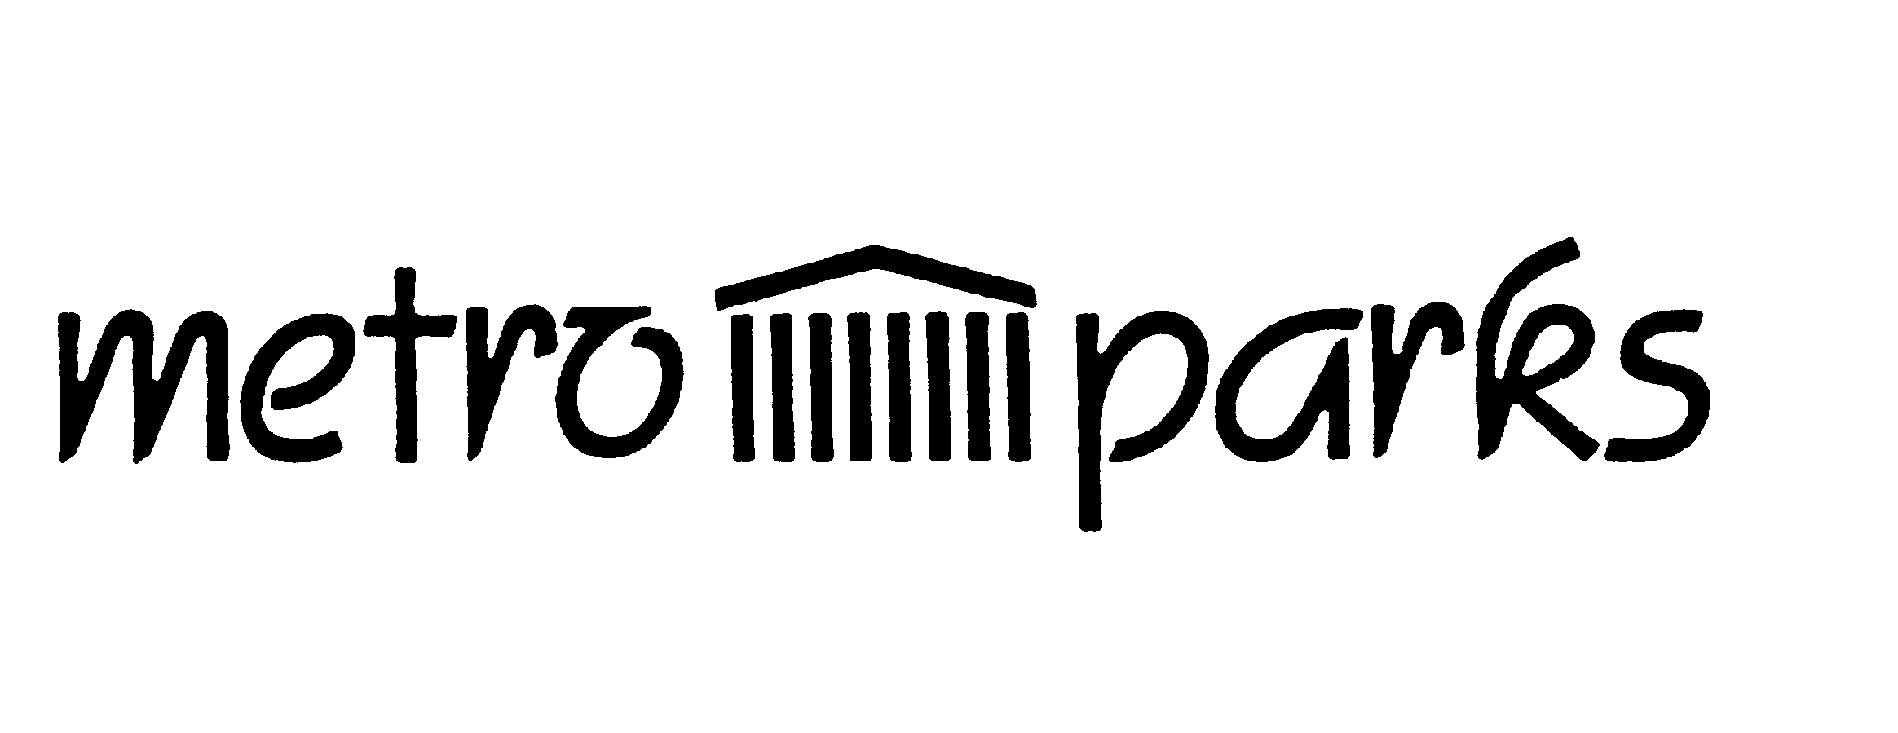
For office use only:
____Approved
____Denied
____Hold
Date:
Metro Nashville and Davidson County Parks
Geocache Placement Site Permit Application

Once you have submitted this application, you will be notified whether your request has been approved. Please follow all placement procedures in order to have your request processed quickly (see “Guide to Hiding”).

Mail the completed form to: Outdoor Recreation Specialist, Warner Parks,
50 Vaughn Road, Nashville, TN 37221 or email: traci.bennett@nashville.gov.

- Name ____________________________ Geocache Name_______________________

- Address _______________________________________________________________

- Phone (____)___________________ Cell or 2nd Phone (____)___________________

- E-mail address __________________________________________________________

- Cache name ____________________________________________________________

- Park Name and Location coordinates__________________________________________

- Nearest parking area (description and coordinates) __________________________________

_________________________________________________________________________

- Physical description of area ________________________________________________

_________________________________________________________________________

- Type of cache ___________________________________________________________

- Physical description of container ____________________________________________

_________________________________________________________________________

The permit is valid for 6 months. After six months, the permit will be reviewed.

We require that you monitor this cache monthly and you maintain it to be family friendly. The cache should contain no food, alcohol, firearms, drugs, dangerous items or adult items. Please direct people seeking your cache to follow established trails. In many areas, we do not allow off trail hiking in order to preserve the natural resources.

Metro Parks has a maximum limit of 50 caches allowed in the park system. The number of caches in each park is limited by acreage; less than 20 acres- 1 cache, 21 to 50 acres- 2 caches, 51 to 100 acres- 3 caches, and greater than 100 acres- 5 caches.
Guide to Hiding a Cache in a Metro Nashville Park
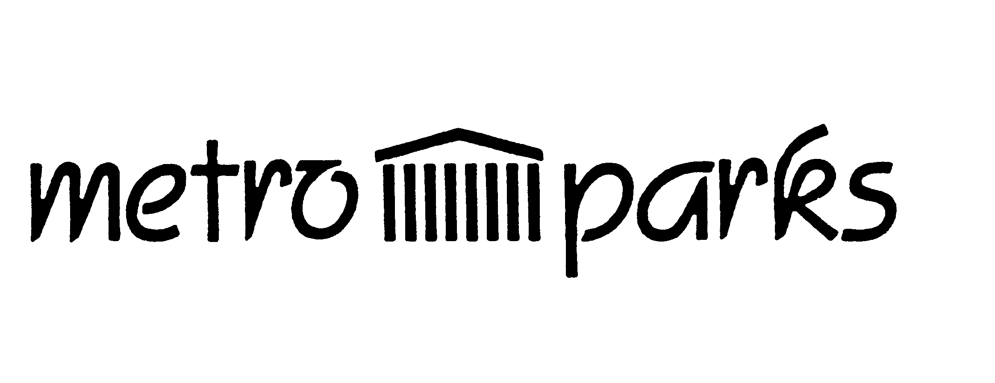
All caches placed on park property must be permitted. This is a guide explaining requirements for having your cache approved. Once you have reviewed and followed these requirements, submit your permit application for approval. For additional information about geocaching, visit www.geocaching.com or call Warner Parks at (615) 370-8051.
Step 1 - Research a cache location
When thinking about where to place a cache in Metro Parks, keep these things in mind:
- Will it be easy to get to? - Try to find a place that will take a bit of time to get to, preferably on foot – Do NOT bury the container or place off trail.
- Will it be easy to find? - If it is too visible, or close to busy roads, trails, etc. there's a good chance someone may stumble upon it. But don't make it too difficult!
- Will the location disturb other park users or the environment? - Be respectful of the areas you are thinking about placing the cache. For example, if it's the location of an endangered species or off-trail with delicate ground cover, keep in mind that others will be walking in these areas. Be mindful to protect the environment, resources, and historical areas found in parks.
- Is the location unique or interesting? - The big reward for geocachers, other than finding the cache itself, is the location. A prime hiking spot, great viewpoint, unusual location, etc. are all good places to hide a cache.
- Will your cache be a traditional or micro? – Depending on the location, decide whether to place a traditional or micro cache.
- Does it meet requirements to be listed on the geocaching.com web site? - Be sure to review the guidelines on geocaching.com for listing a geocache on their web site.
Step 2 - Preparing Your Cache
Use a water resistant, snow resistant, etc. container. Plastic buckets, tupperware (or rubbermaid) containers, or film canisters. Caches in military ammo boxes are NOT allowed in Metro Parks. You will need to attach a Metro Parks and Geocaching.com permit label to your cache so that someone who doesn't play can figure out what it is if they happen upon it. It's also recommended to have a note to welcome the cache finder and let them know what it is all about. Geocaching.com has a letter you can use in both Microsoft Word format and Text format. You can also put goodies in the cache. Keep it fun and family oriented. Some ideas of items placed in cache boxes:
- CDs, Trading Cards, gift certificates, dollar bills, keychains, etc.
- Cheap toys - play-doh, erasers, action figures, etc.
- Do NOT put food or candy in a cache! Critters will bite, nibble or swallow your cache in an attempt to get to the goodies.
- No alcohol, tobacco, firearms, prescription or illicit drugs. The permit is subject to all rules, regulations, and ordinances of the Metropolitan Government.
Step 3 - Report the Cache
Submit your Metro Parks permit application. If the cache is approved, the permit label will need to be attached and a photograph taken of the cache in its park location. Once the picture is received, you are then ready to report the cache to geocaching.com.

Step 4 - Maintain the cache
Once you place the cache, it is your responsibility to maintain the cache and the area around it. Metro Parks permits are only valid for six months. You'll need to return as often as you can to ensure that your cache is not impacting the area, and ensure that the cache is in good repair.

